Physics LW#7 How to synthesize (make) soap from oil and caustic soda

The main stages of a chemical synthesis

1. Chemical reaction
A synthesis allows us to create a chemical thanks to a reaction between chemical reagents.
A soap is formed when oil reacts with a basic solution, such as caustic soda.
The
caustic
soda has a
very high
Concentration:
It is absolutely necessary
to respect the safety instructions :
Tie back long hair
Close your lab coat
Wear gloves and goggles
Experimental setup : The reflux
Carefully insert into the boiling flask:
- 15 mL of oil,
- 20 mL of caustic soda,
- 20 mL of ethanol
- add 4 or 5 pumice stones (pierre ponce).
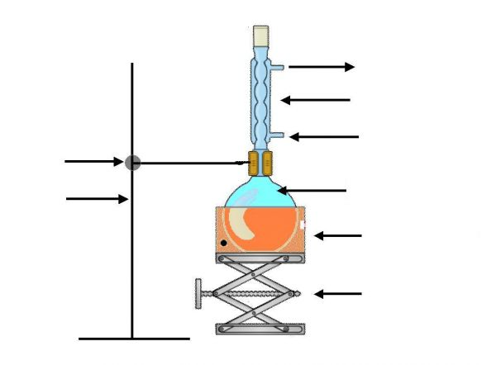
Switch on the water flow inside the condenser. Then switch on the heater at its maximum value. When the mixture starts boiling, decrease the heater to a medium value.

Drawing of a reflux set up

Use of the heater:

Use of the condenser:

Use of the lab jack:

Use of the pumice stones:

2. Separation of the product: solidification and filtration

- solidification :
Experimental procedure : Pour the mixture of the boiling flask into a large beaker filled with iced salted water.

Observation :

Explanation:
Chemical species | Oil | Caustic soda | soap
Solubility in water | Liquid  that is not miscible  in water | Soluble | Soluble
Solubility in salted water | Liquid  that is not miscible  in water | Soluble | A little soluble
Solubility in iced salted water | Liquid  that is not miscible  in water | Soluble | Not soluble

- filtration :

3. Cleaning (We won't have enough time to do this part) Rinse the soap with water (if necessary, make another solidification process)

4. Identification Put a small piece of soap ( ! do NOT touch the soap!) inside a test tube, add water, close the test tube with a stopper and shake it.
Observation and conclusion :

