Physics and chemistry
LW #6 How can we prepare a glucose solution for a perfusion
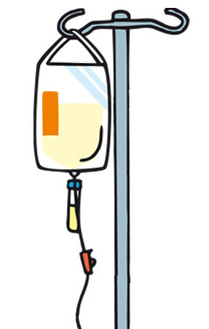
The aim of this lab work is to prepare a solution of glucose, identical to those used for perfusion.

I. The glucose solution for perfusion
The following document shows the label of a glucose solution sold in drugstore.
Composition
Anhydrous glucose50,0 g278 mmol/L
Water1000 mL
Osmolarity ≈ 281 mOsm/L
pH ≈ 4,4
Calory input= 200 Cal/L

- Among all the data of the label, which ones are useful to calculate the mass concentration in glucose of the solution?
- Calculate the mass concentration of this perfusion: C_{perf}.

II. Prepare the solution by dissolving solid glucose

You have to prepare a volume V = 100,0 mL of a glucose solution whose concentration is 5 times less than the perfusion one.
- Calculate: - the concentration of the solution you have to prepare: C_{sol},
- the mass of glucose that you need.
- Prepare the solution, following the chemistry procedure.
- Check the concentration of your solution with a glucose test strip.

III. Prepare the solution by diluting the perfusion solution

You have to prepare a volume V = 50,0 mL of a glucose solution (same
concentration as in question II), by doing a dilution of the perfusion solution.

- Calculate the volume of initial solution.
- Prepare the solution, following the chemistry procedure.
- Check the concentration of your solution with a glucose test strip.

Physics and chemistry
LW #6 How can we prepare a glucose solution for a perfusion
The aim of this lab work is to prepare a solution of glucose, identical to those used for perfusion.

I. The glucose solution for perfusion
The following document shows the label of a glucose solution sold in drugstore.
Composition
Anhydrous glucose50,0 g278 mmol/L
Water1000 mL
Osmolarity ≈ 281 mOsm/L
pH ≈ 4,4
Calory input= 200 Cal/L

- Among all the data of the label, which ones are useful to calculate the mass concentration in glucose of the solution?
- Calculate the mass concentration of this perfusion: C_{perf}.

II. Prepare the solution by dissolving solid glucose

You have to prepare a volume V = 100,0 mL of a glucose solution whose concentration is 5 times less than the perfusion one.
- Calculate: - the concentration of the solution you have to prepare: C_{sol},
- the mass of glucose that you need.
- Prepare the solution, following the chemistry procedure.
- Check the concentration of your solution with a glucose test strip.

III. Prepare the solution by diluting the perfusion solution

You have to prepare a volume V = 50,0 mL of a glucose solution (same
concentration as in question II), by doing a dilution of the perfusion solution.

- Calculate the volume of initial solution.
- Prepare the solution, following the chemistry procedure.
- Check the concentration of your solution with a glucose test strip.

