Physics Periodic Phenomena LabWork#1
I. What is a Periodic Phenomenon?
1. Definition : ………………………..………………………………………………………………………………………………………………………....... ……………………………………………………………………………………………………………………………………………………………………….....

2. Characteristics of a periodic phenomenon (example of an electric voltage)
a. The smaller pattern :
……………….......................................……………………………………………………………………………………………………………………..
……………………………………………………………………………………………………………………………………………………………………….....
b. The period : ……………………………………………………………………………………………………………………………………………………
………………………………………………………………………………………………………………………………………………………………………………
c. The frequency : ……………………………………………………………………………………………………………………………………………………………………………… ………………………………………………………………………………………………………………………………………………………………………………………………………………………………………………………………………………………………………………………………………………………………
………………………………………………………………………………………………………………………………………………………………………………
………………………………………………………………………………………………………………………………………………………………………
d. The maximum voltage and the minimum voltage:
.…………………………………………………………………………………………………………………………………………………………………………… ………………………………………………………………………………………………………………………………………………………………………………
3. Examples :
a. The pulse: (one's pulse represents the tactile arterial palpation of the heartbeat).
- Measure your pulse as the number of pulsations per minute.
.…………………………………………………………………………………………………………………………………………………………………………… - Then, calculate your pulse as the number of pulsations per second. How would a physicist name this number?
………………………………………………………………………………………………………………………………………………………………………………
………………………………………………………………………………………………………………………………………………………………………
-Then, calculate the duration of one pulsation : ………………………………………………………………………………………………………………………………….............................................…………………………………………………………………………………………………………………………………………………………………………..
b. The following graph shows the variation of the electric voltage U (in Volts) as a function of time t (in milliseconds).
0
U (V)
1
-1
2
3
-2
t (ms)
1
2
3
4
5
6
7

- Highlight (with your florescent pens) two smaller patterns with two different colors.
- Draw a double arrow to show the period T on the graph. What is the value of the period?
………………………………………………………………………………………………………………………………………………………………………………
- Calculate the frequency f of this voltage : ………………………………………………………………………………………………………… ………………………………………………………………………………………………………………………………………………………………………………
………………………………………………………………………………………………………………………………………………………………………………
- Show the maximum (U_{Max}) and minimum (U_{min}) voltages on the graph. What are their values?
………………………………………………………………………………………………………………………………………………………………………………

II. Observe an electric voltage on the oscilloscope.
We are going to use a low frequency generator that generates an electric voltage; we will connect it to the oscilloscope (software oscillo5) in order to see the variation of this voltage as a function of time.
The LFG is already adjusted. Don’t touch it!!!!!!
1. Set the oscilloscope
- Connect the LFG to the SYSAM console. Click on the “Active” button so that only U_{AM} remains active.
Watch the graph on oscillo 5.
a. Vertical sensitivity: (“SENS” below the graph) click to choose the voltage so that the signal is the tallest.
b. Horizontal sensitivity (“Balayage” on the right) click to choose the time scale in order to see 1 to 2 patterns.
2. Study of the electric voltage given by the power supply.
Copy out meticulously the curve seen on the screen (You may move the curve horizontally on the oscilloscope) and the sensitivities you have chosen (don’t forget the units).
Vertical sensitivity: …………………………
Horizontal sensitivity ………………………

a. Highlight one smaller pattern.
b. Draw a double arrow to show the period T on
the graph.
c. Calculate the value of the period T.
…………………………………………………………………………
…………………………………………………………………………
…………………………………………………………………………
d. Calculate the frequency f :
………………………………………………………………………….................................................................................................
e. Show on the graph the maximum and the minimum voltages. What are their values?……………………………………………………………………………………………………………………………………………………………
Remarque : pour revoir les réglages de l’oscilloscope, voir les animations d’électricité du site suivant : http://physiquecollege.free.fr/troisieme.htm
III. Another example : study of an electrocardiogram (or ECG)
1. We are going to use the specific sensors to record two ECG : the first one when you are at rest, and the second one after 30 legs’ flexings.
a. Use the most accurate method to find the periods T₁ and T₂ of the ECGS
…………………………………………………………………………………………..................................................................................
……………………………………………………………………………….............................................................................................
……………………………………………………………………………………………………………………………………………………………………………………………………………………………………………………………………………………………………………………………………………………
b. Calculate their frequencies f₁ and f₂. …………………………………………………………………………………………………………
…………………………………………………………………………………………………………………………………………………………………………
…………………………………………………………………………………………………………………………………………………………………………
2. Exercise :
Tachycardia and bradycardia are two types of cardiac pathologies. Tachycardia corresponds to the sharp increase of the heart rate. On the contrary, bradycardia corresponds to the slow of the heart rate; it sometimes results in cardiac arrest.
a. In which case, will the period be higher than the one of a « normal ECG » ?…………………………………………………
………………………………………………………………………………………………………………………………………………………………………………………………………………………………………………………………………………………………………………………………………………………………………………………………………………………………………………………………………………………………………………………………
b. In which case, will the frequency be higher than the one of a « normal ECG » ?……………………………………………
………………………………………………………………………………………………………………………………………………………………………………………………………………………………………………………………………………………………………………………………………………………………………………………………………………………………………………………………………………………………………………………………
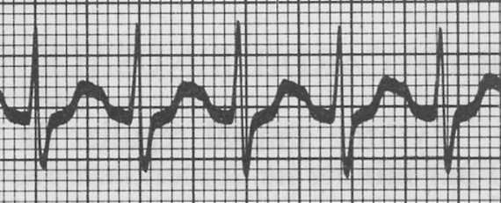
c. The following ECGs are made with a scale of 1 division for 0.20s.
ECG 2
Calculate the period of each ECG ; then find wich one corresponds to a « normal heart », to a heart suffering from tachycardia, and to a heart suffering from bradycardia.
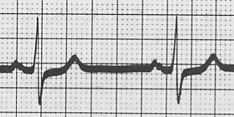
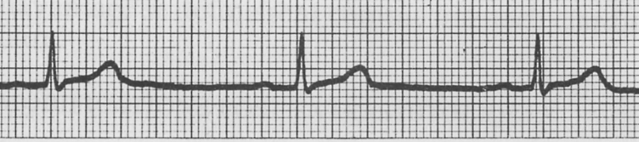
ECG 1
ECG 3

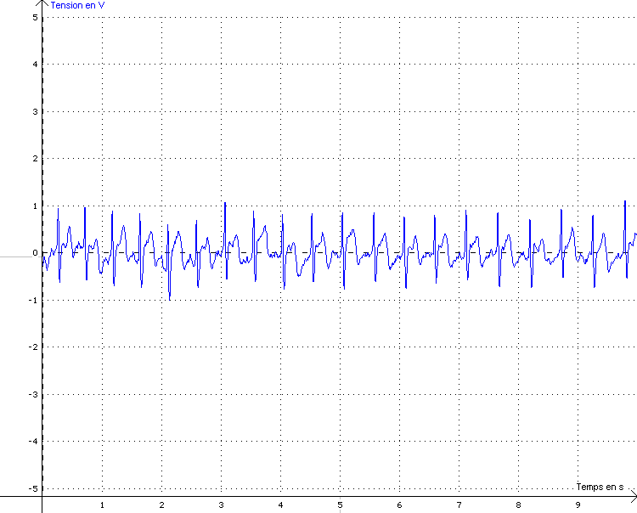
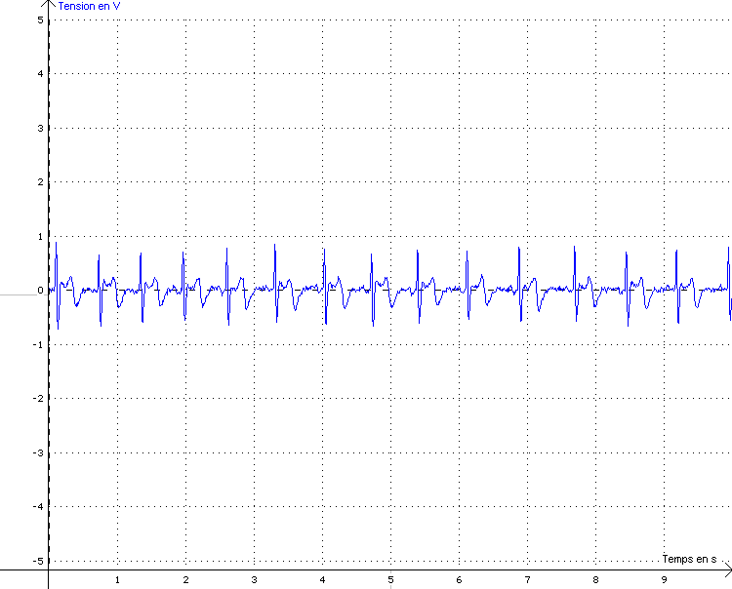
ECG at rest :
Voltage as a function of time
ECG after flexings :
Voltage as a function of time

